**CSE 145/237D**

E4E Mangrove Monitoring - GPS and Canopy Height

**April 18, 2019**

#### Project Charter

# Project Overview

Mangrove forests are one of the most productive ecosystems in the world. The different species within a mangrove forest on the coast can be home to a wide variety of fauna and flora, help mitigate the effects of tropical storms and tsunamis, all while sequestering carbon at an amazing rate in their massive biomass. In Baja California, the 3 prevalent mangrove species present are threatened by increased development and dumping.Thus, the classification and tracking of these mangrove species is very important to their preservation. 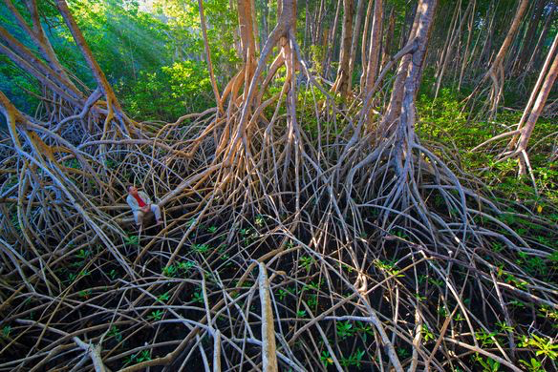

# Project Approach

Using imagery from consumer drones that has been recorded at a lower altitude can achieve a higher spatial resolution in order to resolve details that could not have been resolved otherwise in satellite imagery in order to take advantage of newer technologies to track mangrove statistics such as species and canopy height. We need images that use highly accurate geographical alignment using GPS coordinates in order to create quality images, and truly accurate measurements of the mangrove canopy height in order to create the most accurate statistics. However, the current methods of getting GPS coordinates and canopy height measurements can be inaccurate and cumbersome. In order to solve the problems outlined above, we have planned solutions for each:

GPS Coordinates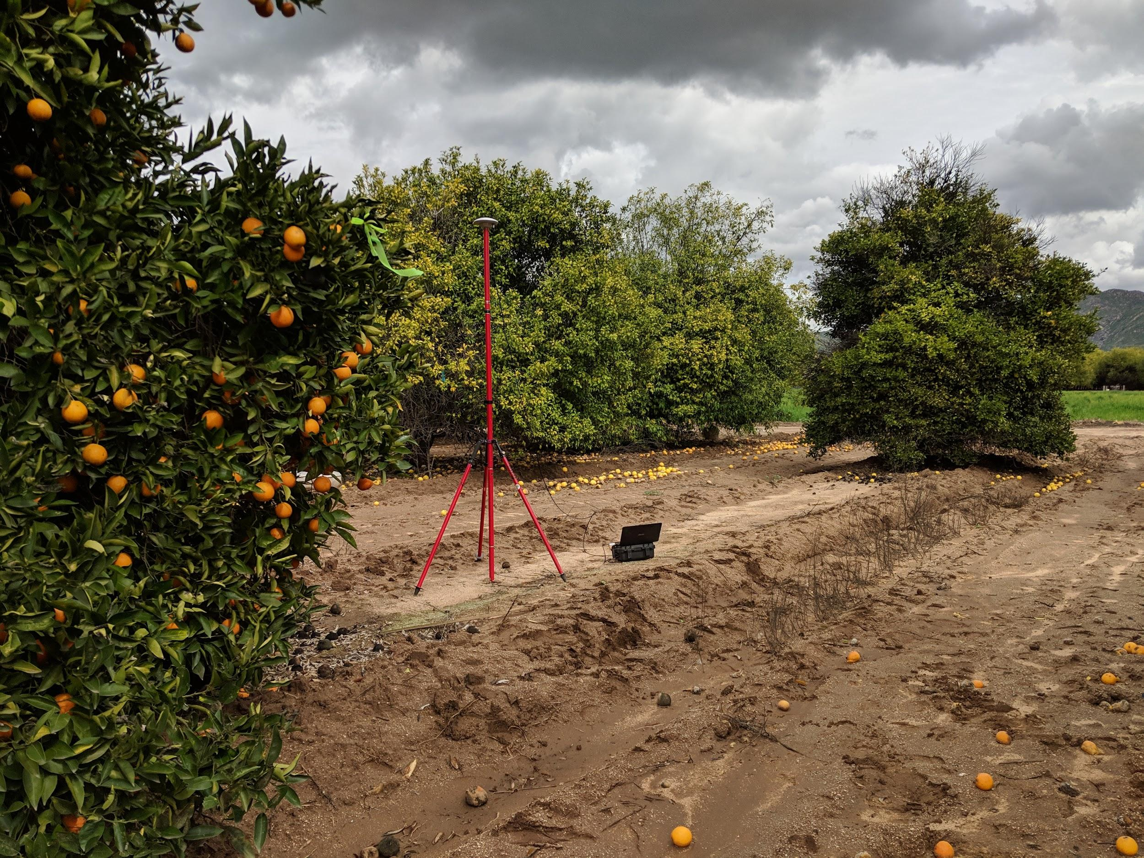

The method that we are using in order to get GPS measurements is relatively simple and will hopefully be very powerful. We will get a waterproof case such as a pelican and put a GPS device capable of Real Time Kinematics and a Raspberry Pi inside in order to take accurate GPS measurements. This device will include a screen and intuitive user interface in order to take the current location of the device in addition to barometric data to be combined with canopy height estimation barometric readings. This device will hopefully be much cheaper than current sensors that exist, costing around ~500 dollars compared to many survey grade devices that are multiple thousands and are much more cumbersome to use in the mangrove ecosystem.

Canopy Height Estimation

So far we have several different candidate approaches for estimating the canopy height:

1. Pole approach. Mount a camera and barometer to the end of a telescopic pole. Operator monitors camera while raising pole until reaches the top of the canopy, then takes the barometer measurement. We can probably get a 10 meter pole for under $100. We are waiting on quotes for 20 and 25 meter poles, but believe this will be an order of magnitude greater cost.

2. Drone relay station. First, obtain GPS and barometric measurements from the ground team. Use a first drone solely as a communications platform equipped with a radio transceiver. The operator controls a second drone by redirecting the radio controls via the communications platform, eliminating the need of line of sight. The operator navigates the measurement drone to the previously acquired GPS coordinates. The measurement drone drops a sensor pod equipped with a camera and barometer via string until it reaches the canopy height. The operator makes a note of the sensor pod height, and takes the difference between the ground and air measurement.

3. Pole relay station. Same approach as drone relay station, but mount the radio transceiver on a pole with the operator. This allows for a better angle but will still require line of sight from the top of the pole to the drone. Similar to the original pole approach, pole costs will vary as height requirements change.

Each approach shares the sensor pod composed of a camera, barometer, microcontroller, and radio transceiver. Therefore while we continue to evaluate the pros and cons of each approach as well as communicating with our stakeholders (Scripps Institute), we will be able to make progress on the project as a whole.

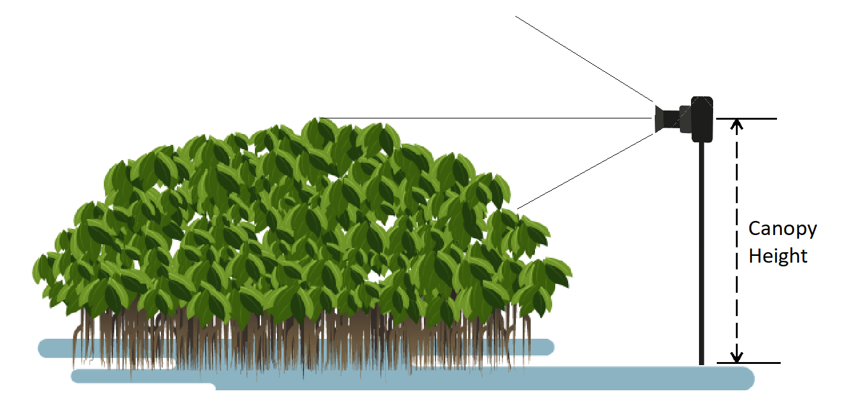

*Proposed height measurement method*

### Team Members

Dillon Hicks - Technical Lead

Kathy Qi - Biomass Lead

Jeremy Smith - Developer

Mark Liu - Developer

# Project Objectives, Milestones, and Major Deliverables

### Objectives

1. **Accurate GPS Coordinates:** In order to get accurate alignment of our images and DEM’s accurate GPS Coordinates are needed inside the mangroves.
2. **Weatherproofed GPS Device:** Since a mangrove forest is very rugged, wet terrain, a weatherproofed device is needed in order to resist the elements at hand.
3. **Canopy Height Approximation:** Provide a low-cost and accurate solution for estimating the canopy height of mangrove forests.

### Major Milestones

GPS Tracking Milestones

1. Create Sketches of GPS Device
2. Get GPS coordinates and the Barometer on Raspberry Pi
3. Create basic UI of GPS Software
4. Create Laser cut drawings of front panels after parts arrive
5. Create CAD designs for backplate of front panel
6. Assemble device
7. Optimize UI to make device much easier to use in the mangrove forests

Canopy Height Estimation Milestones

1. Determine Project Approach. Before beginning work, we must come up with ideas and determine what the project will entail.
2. Construct the system. Once the approach has been solidified, materials must be obtained, and work on constructing the system undergone. This involves implementing the various hardware and software components.
3. Testing the system. Throughout the development process, testing should be done iteratively. Once the system has been put together, systems tests should be done. Ultimately, the entire system will be tested in the field.
4. Documenting the System. Maintain appropriate level of documentation to outline the process we have gone through. Provide a document that can be used to replicate our system and to train a new user to utilize the system effectively.

### 

### 

### 

### 

### 

### 

### 

### Major Deliverables

GPS Tracking

1. Device to receive very accurate GPS waypoints of mangrove quadrats and ground control points. This will be delivered by Dillon and Kathy and is planned to be delivered by week 9
2. Intuitive User Interface to get waypoints in addition to easy waypoint downloading and usage of other tools. Documentation will also be provided to users by the end of the quarter. This will be delivered by Dillon and Kathy and is planned to be delivered by the end of the quarter

Canopy Height Estimation

1. Device to accurately measure the height of mangrove forests. This will primarily be delivered by Jeremy and Mark and is planned to be delivered by week 8.
2. Instruction set for future users to easily and effectively deploy and use the height estimation tool. This will primarily be delivered by Jeremy and Mark and is planned to be delivered by the end of the quarter.

Final project report. This will be delivered by the end of the quarter by all team members

Potential longer term deliverables include real data obtained from deploying our two systems in real mangrove forest environments.

# Constraints, Risk, and Feasibility

GPS Tracking

Much of this quarter will likely be spent on creating a good user interface for the device in order to make the device as easy as possible to use in the mangrove ecosystem. We already have a set plan in how we want to execute the construction of this device, as many of the components are easily usable and the sensors require little setup to get accurate readings.

The focus of the GPS tracker is on polish, as we want to make a device that is not just a proof of concept, but as an actual usable device that can be deployed to mangrove ecosystems and in any other uses where a portable high accuracy GPS measurements are needed.

Therefore, our most significant risk is not meeting expectations of the polish of the project. Therefore, we hope to implement many rapid prototyping workflows and work closely with mentors and collaborators to ensure that our device is up to the task to be a practical tool.

Canopy Height Estimation

We will need to take special care to ensure we narrow in on a single approach for canopy height estimation quickly so that we can order and receive the necessary parts in time. Many of the potential components are shipping from foreign manufacturers and may therefore take a long time to arrive.

We are aiming to implement a low-cost solution for the canopy height estimation project. Therefore the budget is one of our important constraints that we will need to keep in mind when determining our approach for the project.

Our most significant risk is spending too much time in the planning phase. We can work around this risk by identifying the components shared among all approaches and prototype early.

#### Group Management

# Major Roles

Dillon Hicks - Technical Lead

Mark Liu - Developer

Kathy Qi - Biomass Lead

Jeremy Smith - Developer

# Administration

Decisions will typically be made by consensus with the final say going to the leads of the project and in the E4E organization. Communication is done over Slack, in person spontaneously, and at planned weekly in-person meetings. We will make a plan of action to monitor our progress against the schedule presented in this document. At meetings we will discuss our progress and update our plans accordingly. Each member of the team is responsible for their assigned or shared tasks. We will primarily be working together as much as possible on each task to ensure flow of communication and to ensure each member of the team is contributing.

#### Project Development

As a team, we will all be contributing to various development tasks, both hardware and software.

Hardware/Software Needs: We plan to write all of our own software responsible for controlling the various hardware components and analyzing the collected data.

### 

### 

### 

### 

### GPS Tracker Hardware

|  |  |  |  |
| --- | --- | --- | --- |
| Item | Quantity | Price | Link |
| Raspberry Pi B 3+ | 1 | $38.10 | [amazon](https://smile.amazon.com/ELEMENT-Element14-Raspberry-Pi-Motherboard/dp/B07BDR5PDW/ref=sr_1_4?keywords=raspberry+pi&qid=1554921919&s=gateway&sr=8-4) |
| Lipo Battery Pack | 1 | $29.50 | [adafruit](https://www.adafruit.com/product/353) |
| Adafruit PowerBoost 1000 Charger | 1 | $21.54 | [amazon](https://smile.amazon.com/gp/product/B01BMRBTH2/ref=ox_sc_act_title_1?smid=A20H7HZMYKP2JK&psc=1#customerReviews) |
| Waterproof USB Connector | 2 | $10.98 | [amazon](https://smile.amazon.com/CNLINKO-Connector-Waterproof-Industrial-Standard/dp/B01N1LWWDH?ref_=bl_dp_s_web_16563196011) |
| Waterproof Switch | 1 | $7.99 | [amazon](https://smile.amazon.com/dp/B01J0PFX3Y/ref=psdc_15734681_t2_B00PWYLIPK) |
| Waterproof Buttons | 2 | $11.99 | [amazon](https://smile.amazon.com/Button-Switch-Waterproof-Switches-Motorcycle/dp/B076RLL1KM/ref=cm_cr_arp_d_product_top?ie=UTF8) |
| 5 inch TFT screen | 1 | $29.95 | [adafruit](https://www.adafruit.com/product/1680) |
| TFT Screen Driver | 1 | $24.95 | [adafruit](https://www.adafruit.com/product/2353) |
| USB Hub | 1 | $4.95 | [adafruit](https://www.adafruit.com/product/2998) |
| Slim HDMI Cable | 1 | $9.95 | [adafruit](https://www.adafruit.com/product/2420) |
| GPS Antenna | 1 | $64.95 | [sparkfun](https://www.sparkfun.com/products/15192) |

### Canopy Height Hardware

|  |  |  |  |
| --- | --- | --- | --- |
| Item | Quantity | Price | Link |
| FPV drone camera and transmitter. | 1 | $16.55 | [amazon](https://www.amazon.com/Wolfwhoop-WT05-Transmitter-Antenna-Quadcopter/dp/B06XJMQQ6Y?ref_=fsclp_pl_dp_9) |
| Radio Video Receiver | 1 | $24.99 | [amazon](https://www.amazon.com/Receiver-Auto-scan-Snowflake-Function-Smartphone%EF%BC%88Black%EF%BC%89/dp/B07L4CHF85?ref_=Oct_MWishedForC_2234130011_2&pf_rd_r=QPTXJKD59HXQNAZ3ESD1&pf_rd_p=15b52061-9b8d-5b79-8a3c-99f0b1b758a4&pf_rd_s=merchandised-search-6&pf_rd_t=101&pf_rd_i=2234130011&pf_rd_m=ATVPDKIKX0DER) |
| Radio Transceiver Set | 1 | $10.98 | [amazon](https://www.amazon.com/Arduino-NRF24L01-2-4GHz-Wireless-Transceiver/dp/B07GZ17ZWS/ref=asc_df_B07GZ17ZWS/?tag=hyprod-20&linkCode=df0&hvadid=319972287270&hvpos=1o5&hvnetw=g&hvrand=10321075618535084605&hvpone=&hvptwo=&hvqmt=&hvdev=c&hvdvcmdl=&hvlocint=&hvlocphy=9053667&hvtargid=pla-614182851063&psc=1) |
| Barometer | 1 | $13.95 | [sparkfun](https://www.sparkfun.com/products/9721) |
| Arduino Nano | 2 | $8.99 each | [amazon](https://www.amazon.com/ATmega328P-Microcontroller-Board-Cable-Arduino/dp/B00NLAMS9C) |
| Battery | 2 | $12.95 | [sparkfun](https://www.sparkfun.com/products/13855) |
| Monitor (or borrowed tablet device) | 1 | Free or $34.95 | [manodeg](https://manodeg.com/products/android-4-4-9-quad-core-n98?variant=27697193812040&utm_medium=cpc&utm_source=google&utm_campaign=Google%20Shopping) |
| (Tentative) Telescopic Pole | 1 | 60 pounds | [gangster pole](https://www.anglingdirect.co.uk/ron-thompson-gangster-pole) |

May need to reconsider the battery. We can figure out how much power we need to power the video transmitter, receiver, transmitter, etc. Also need to figure out how we want to record the data. (Do we want to store the data in something like a raspberry pi to be reviewed later or have the scientists record the barometric pressure on the spot)

OSD Chip to overlay on analog video feed

Need to consider video transmitter might tilt

* (possibly install an IMU)
* Possible hang the camera transmitter like a pendulum

Items from Amazon will arrive within 3 days. Items from Sparkfun may take up to 11 days.

Depending on the chosen method of sensor pod delivery, we may incur additional costs. For the pole-based approach, prices range from under $100 to $600 depending on pole ranges from 10 to 20/25 meters. If we were to use a drone-based delivery system, we would be able to use existing E4E drones.

Testing will be done iteratively as software is developed and integrated with hardware. We plan to run integration tests between software and hardware for every different component. When the system comes together, system tests will be done to ensure the whole system works together as expected. Finally, field tests will ensure that the system works in the real world outside of controlled lab settings. Any failed tests will result in action items to fix the discovered issues.

We will record different approaches we came with along with pros and cons of each methodology. We will also record outcomes of tests, discovered issues and the resulting plan of resolution, and the people assigned for each task. We will be keeping track of all the abovementioned documentation with our shared Google Drive folder.

#### Project Schedule

*Key Milestones:*

* Determine Project Approach. Before beginning work, we must come up with ideas and determine what the project will entail.
* Construct the system. Once the approach has been solidified, materials must be obtained, and work on constructing the system undergone. This involves implementing the various hardware and software components.
* Testing the system. Throughout the development process, testing should be done iteratively. Once the system has been put together, systems tests should be done. Ultimately, the entire system will be tested in the field.
* Documenting the System. Maintain appropriate level of documentation to outline the process we have gone through. Provide a document that can be used to replicate our system and to train a new user to utilize the system effectively.

*Weekly Milestones:*

Week 2:

* Brainstorm and propose feasible methodologies. The ideas are proposed to the team as a whole and discussed.
* Each team member does independent research evaluating the pros and cons of their approach. Team members keep track of notes outlining potential problems or benefits.

Week 3:

* Commit to single methodology as a group.
* Each team member continues doing research into the different proposed methodologies to determine which are feasible. Team members continue to compile notes of any important considerations discovered.
* A group consensus is arrived at to determine the single approach to take. The demonstration of completion from this milestone is this document.

Week 3/4:

* Plan out architectural components with description of entire system. As a group, break apart the design into the various components and determine the requirements of each piece.
* Create a diagram showing how the system fits together.

Week 4/5:

* Begin software design and implementation for non-hardware related components. Completion of this milestone entails showing any code developed to team as well as any diagrams outlining software design.
* Obtain required materials for hardware implementation.

Week 5/6:

* Implement the required software to interface with hardware components.
* Run integration tests to ensure hardware and software are communicating properly. Outcome of tests and any resulting action items will be recorded.

Week 7:

* Assemble all hardware and software components into the system.
* Run system tests to ensure that the system functions as expected in a lab setting. Outcome of tests and any resulting action items will be recorded.

Week 8:

* Run field tests. Take the system out and ensure that it works. Outcome of tests and any resulting action items will be recorded.
  + Eucalyptus Grove, Canyon behind Warren….

Week 9:

* Complete final project report
* Prepare for final presentation video

Week 10: (As time permits, useful but not high priority)

* Finalize document outlining the system and the intended usage. Provide information detailed enough to replicate the system and train a new user to utilize the system effectively.